**MTE 203 – Advanced Calculus**

**(Fall 2022)**

**MATLAB Laboratory 2 Worksheet [1]**

Cameron Ritchie

20877299

**Objectives**

1. Learn how to define domains of function of 2 variables using the **meshgrid** command.
2. Learn how to plot contour maps of functions of 2 variables using the **contour** command.
3. Learn how to plot curves in 3D using the **plot3** command.
4. Learn how to plot surfaces in 3D using the **surf** and **surfc** commands and, in the process, plot the intersection of 3D surfaces

**Part 1: Plotting 3D Surfaces**

In this part, you will define the domain for two functions of 2 variables using the **meshgrid** command and plot their respective 3D surfaces using the **surf** command.

Consider the equation of the following first 3D surface,

(1)

1. To plot the 3D surface given by (1), you will first need to rewrite the equation as a multivariable function . Provided that is always positive, rewrite the equation of the 3D surface as a function of 2 variables in the following form for positive ,

***Use the following space for your mathematical derivations and final equation:***

|  |  |  |
| --- | --- | --- |
|  |  | (1) |

Can be solved as a quadratic equation, but using the positive values only.

|  |  |  |
| --- | --- | --- |
|  |  | (2) |
|  |  | (3) |

1. Create a Matlab script using the ‘**surf**’ and ‘**meshgrid**’ functions to plot the 3D surface given by obtained in part a. Use the rectangular domain with increment sizes . For the color, use plain red with a transparency of 70%. Name your script “**Eq1Surf.m**”

***Insert your plot below:***

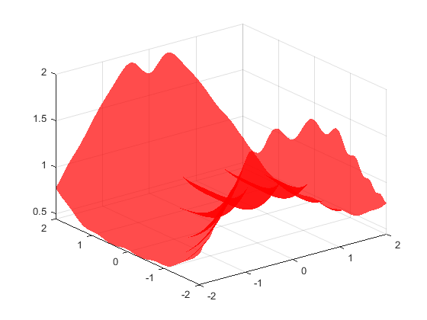

Now, let us plot the second 3D surface given by the following equation:

(2)

1. Create a new Matlab script using the ‘**surf**’ and ‘**meshgrid**’ functions to plot the 3D surface defined by equation (2). Use the same rectangular domain and increments used for the 3D surface defined by equation (1). For the figure, use plain yellow with the default transparency. For the z domain use . Name your script “**Eq2surf.m**”

**Hint:** For this plot, it is better to apply a mesh grid between and then use for both the x-axis and y-axis.

***Insert your plot here*:**

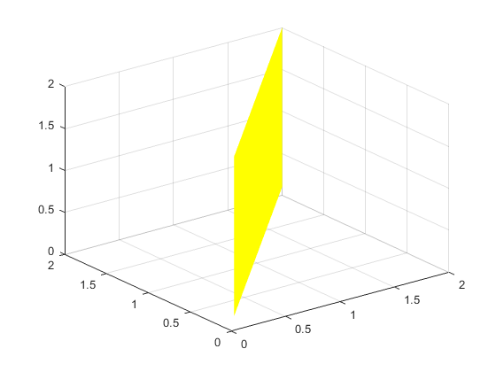

**Part 2: Plotting Contour Maps**

In this part, you will plot the contour map of the 3D surface defined by equation (1) in part 1. Create a new Matlab script and use the Matlab ‘**contour**’ function to draw the level curves of the 3D surface and construct a contour map in the x-y plane. In your plot, use a total of 8 level curves and label each level curve with its corresponding numerical value. Name your script “**Eq1Contour.m**”

***Insert your plot here:***

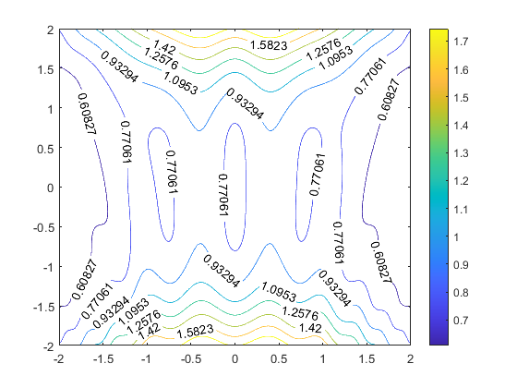

**Part 3: Plotting 3D curves**

In this part, you will plot the 3D curve of intersection of the surface described by equation (1) and the surface described by the equation,

(2)

such that both and increase when increases, using the **plot3** command.

1. To plot the intersection curve between these two 3D surfaces (1) and (2), you need to first find the parametric equations of the curve of intersection. Using the parametrization and , write the parametric equations of the curve of intersection between the two 3D surfaces represented by equations (1) and (2).

***Use the following space for your mathematical derivations and final parametric equations:***

|  |  |  |
| --- | --- | --- |
|  |  | (1) |
|  |  | (2) |

For the purposes of graphing, the plus-minus sign will not be added in the matlab script.

1. Create a Matlab script using the ‘**plot3**’ function to plot the intersection curve starting at and ending at . To make the figure smoother, sub-divide the domain of into 1000 equally spaced divisions using the ‘**linspace**’ function. Plot the intersection curve using the dash-dot blue color as the line type, with a line width of 2. Name your script “**Intrsc.m**”. Please use [0.1,2] as the limits of z axis.

***Insert your plot here:***

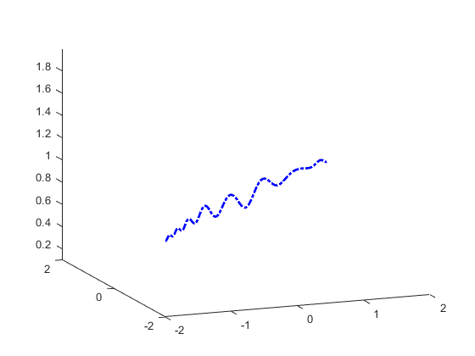

**Part IV: Plotting surfaces, curve of intersection and contours in one single figure.**

Plot the two 3D surfaces defined by equations (1) and (2), their curve of intersection and the contours for the 3D surface (1) in one single figure using the appropriate Matlab functions.

Choose your own colors, transparency and edgecolor **(be creative!)**. Add a title, grid and proper labels and legends. Name your script “**Snglgrph.m**”

**Note:**

For more information on using the command “**surfc**” please refer to the mathworks website (<https://www.mathworks.com/help/matlab/ref/surfc.html>).

For more information on using the command “**contour**” please refer to the mathworks website (<https://www.mathworks.com/help/matlab/ref/contour.html>).

***Insert your plot here*:**

**NOTE:**

**Make sure you LABEL all the essential parts in your graphs indicating the x, y, and z-axes.**

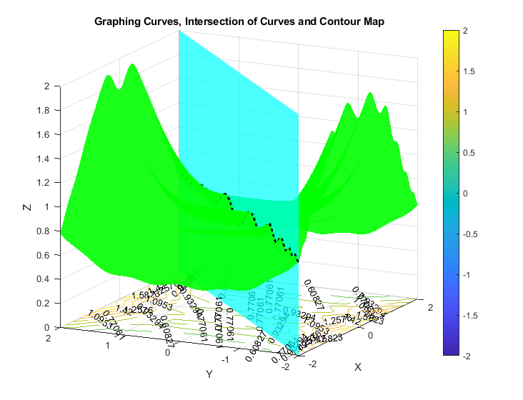

**LEARN Submission:**

Upon finishing your worksheet, your file should include,

* An expression z=f(x,y) for the 3D surface described by equation (1)
* The parametric form of the curve of intersection of the surface and plane (i.e. x(t),y(t),z(t))
* All 5 plots as specified

You also should have generated the following *.m files:

1. Eq1Surf.m
2. Eq2Surf.m
3. Eq1Contour.m
4. Intrsc.m
5. Snglgrph.m

**Make sure that you submit two files:**

1. Your MatLab Laboratory Worksheet 2 file saved as a **pdf** and named as **W2_name_lastname.pdf**
2. All associated *.m files listed above inside **one single zipped file** named **W2_code_name_lastname.zip**

**IMPORTANT:**

To submit your files, please use the “**MTE 203 Matlab Worksheet 2 Dropbox**” in LEARN. **Please note that the dropbox will accept only one submission.**

1. Please note that this Laboratory Worksheet must reflect your individual work and that submissions are individual